RE: Green Line Extension Maintenance Facility Location & Size
The Massachusetts Executive Office of Transportation’s (EOT’s) preliminary recommendation to locate the Green Line Maintenance facility in Yard 8 [see map] should be rejected. A Yard 8 facility would:

- take the prime, central developable land;
- rob the leanest municipal government of millions of tax dollars in one generation;
- widen the gulf between the InnerBelt and Brickbottom areas;
- choke off prospects for InnerBelt/Brickbottom road and pedestrian access;
- discourage dense urban residential development; and
- nix a “junction station” serving both InnerBelt/Brickbottom and the Union Square spur.

Two alternatives, both in the InnerBelt and previously recommended by the Somerville Chamber of Commerce, need to be more aggressively examined:

- co-location of the Green Line Maintenance Facility within the sprawling 30-acre Commuter Rail Maintenance Facility complex [Orange]; or
- siting the Green Line Maintenance Facility alongside the Commuter Rail facility in the 23-acre Yard 7 [Yellow].
- using a combination of the above two parcels to accommodate the Green Line Facility.

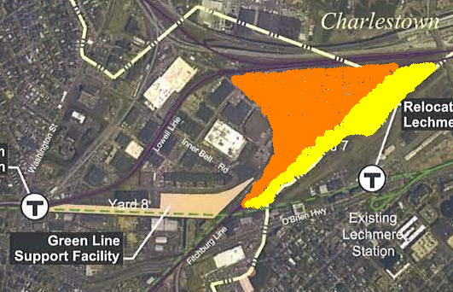

The size of the Green Line facility should mirror the Extension’s proportion of the full Green Line. The agreement to mitigate the Central Artery and Tunnel project did not require that Somerville absorb any more regional infrastructure.
Somerville already bears 100% of the maintenance burden for the Rockport, Haverhill, Lowell and Fitchburg commuter lines with 0% of the service. The size of the Commuter Rail facility also needs to be reexamined. A possible new facility on the South Shore may discontinue the practice of maintaining South Station’s locomotives in Somerville and, so, create excess capacity.

To aggressively examine these alternatives under current time constraints, the City of Somerville needs to:

- engage a third party engineering firm with experience in LRT and commuter rail facilities;
- press immediately for interagency collaboration among the EOT, MBTA, commuter rail officials, and the Massachusetts Bay Commuter Rail Company; and
- discuss with the City of Cambridge and North Point developers the unfavorable consequences of use of Yard 8 (e.g. relocation of the Waste Management Facility after 2016 to Yard 7 adjacent to North Point)

